
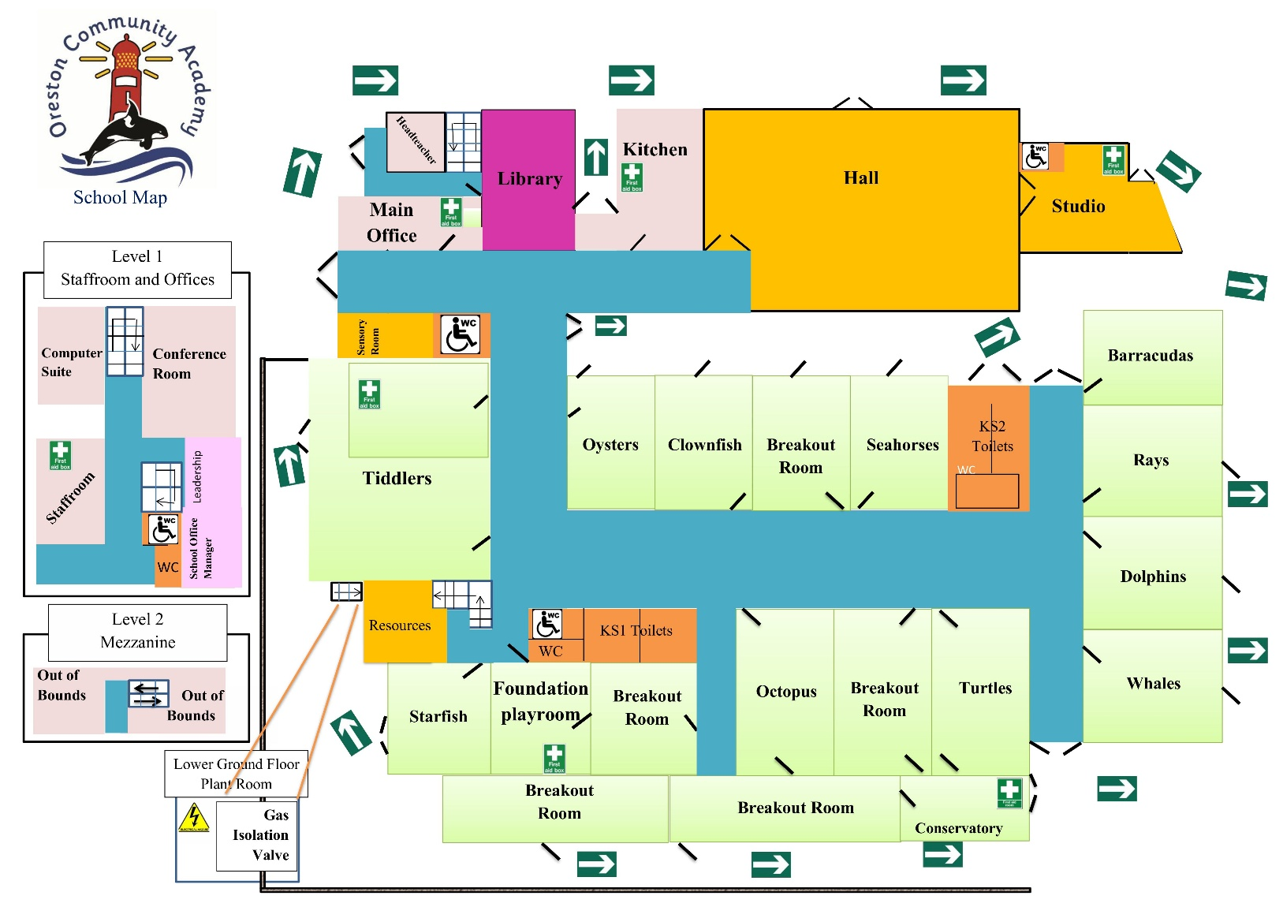

Oreston Community Academy
Visitor Information

Safe-Happy-Included-Learning

- Please switch off mobile phones on entry to the school.
- Ensure your visitor badge is visible at all times.
- No smoking or vaping on the school premises.
- Remember to sign out and hand your badge into reception when leaving.

Toilets: Visitors may only use designated staff toilets. Please ask at Reception if you need directions.

First Aid and Accidents: If you require first aid, please tell a member of staff or return to Reception. Signs on the back of doors identify staff with enhanced First Aid training, and the majority of staff have basic First Aid training. If further assistance is required, advice will be sought from an enhanced First Aider.
In an emergency first aid situation, the Office must be alerted. Red Cards are available in rooms and Club Registers and are used to alert the Office that additional support is required.

Allergy Awareness: We are an allergy-aware school. Please do not bring in or share food unless this has been agreed with the school. Spare adrenaline auto-injectors (AAIs) are held in the Main Office for emergency use by trained staff.
Fire and Evacuation: If you discover a fire, immediately activate the nearest break-glass point to sound the alarm. If the fire or evacuation alarm sounds:
- Leave by the nearest safe fire exit, following the green arrows.
- Do not delay your exit to collect belongings.
- Close windows and doors behind you where it is safe to do so.
- Go immediately to the assembly area on the main playground.
- Visitors should report to muster point Oval 16, remain with their host and ensure they have been accounted for.
- Do not leave the site or re-enter the building until the all-clear has been given.

Lockdown/Invacuation: If the lockdown or invacuation signal sounds, follow staff instructions immediately. Go to the designated safe location, remain quiet, switch your phone to silent and do not leave until a member of staff tells you it is safe to do so.
Before beginning your visit: Please ensure you understand the information provided, including the safeguarding and emergency arrangements. If you have any questions, please ask Reception before meeting your host.

Welcome from Amy Chivers

It gives me great pleasure to welcome you to Oreston Community Academy. I feel very proud and privileged to be Headteacher of such a great school. As a staff, we are dedicated to providing the children in our care with exceptional learning experiences within our highly positive and inclusive school environment.
Staff and children at Oreston always strive to achieve their very best. We recognise all children as unique individuals and aim to celebrate and nurture their talents and interests. I firmly believe that children need to feel safe and happy in order to learn, and we endeavour to ensure every child is valued, supported and challenged to achieve their full potential.

I hope this gives you a flavour of Oreston Community Academy. Please ask if you require any further information. Enjoy your time with us and we hope to see you again soon.
General Information
Security: All visitors must report to Reception, where their identity, purpose of visit and host will be confirmed as part of the school’s signing-in and checking procedures. Visitors will be issued with the appropriate visitor badge or lanyard, which must be worn and visible at all times. Reception will explain any escort arrangements that apply to your visit. Please keep your belongings with you and return your visitor pass to Reception when signing out.

Safeguarding: Safeguarding is everyone’s responsibility. If you see or hear anything that concerns you about a child, please report it immediately to the Designated Safeguarding Lead (DSL) or another member of staff. Please do not investigate the concern yourself or promise confidentiality. Reception will highlight the relevant safeguarding and emergency information when you sign in.

Designated Child Protection Officers:
Mrs Amy Chivers Mrs Lindsay Greenway Mrs Susanne Parker


Mobile Phones and Devices: Oreston Community Academy is a mobile phone-free zone. Mobile phones, smart watches and other devices must not be used to take photographs, video or audio while on site. Please keep your phone switched off or on silent and out of sight. If you need to make or receive an urgent call, please speak to Reception first and use the designated staff area.



